How do I "stack" marginal gains?
Progression note
This article is relevant for learners who have completed the Marginal gains lesson in Fundamentals 1.
What does "stacking" marginal gains mean?
The process of making improvements that add value and build on top of existing progress is known as "stacking" marginal gains. Marginal gains can be considered as "stacking" if they contribute to the development of skills in a productive manner.
Note: For information on tracking marginal gains, please read the article - How do I track Marginal Gains.
Some examples of this are given below.
Good example: Identifying the right kind of skills
In this example, the student is stacking marginal gains by identifying which kind of skill is likely to help them achieve a 1% improvement.
Rayla finds note-taking very time-consuming and decides to improve her skills through marginal gains.
She aims for a 1% improvement in her note-taking skills by “processing difficult concepts into fewer keywords”.
Upon reflection, she notices an improvement in her retention. However, she still finds it time-consuming to process keywords. As her subsequent marginal gain, she thinks of two options:
- Focusing on BEDSM to reduce procrastination, or
- Focusing on Prestudy to identify big-picture ideas.
Both options may lead to an improvement. However, close observation reveals that:
- "Focusing on BEDSM” does not build upon the progress achieved in “processing difficult concepts.” This is because even if Rayla reduces procrastination, it doesn't enhance her deep processing and higher-order thinking, which are necessary for effective note-taking.
- In contrast, "Focusing on Prestudy" directly builds upon the progress achieved in “processing difficult concepts” because it helps Rayla quickly understand key ideas. This strengthens deep processing and higher-order thinking skills, adding more value to the existing progress in note-taking skills.
- Therefore, “Focusing on Prestudy” will “stack” the marginal gains.
Bad example: Switching between multiple skills frequently
Why is it important to stack marginal gains?
Stacking marginal gains is one core technique that helps us achieve optimal skill development by fulfilling the three requirements of efficient skill development.
These three requirements are that we:
- Focus on important skills that make a difference to our ability
- Persist at improving this skill long enough to identify mistakes, overcome them, and eventually develop habitual competence
- Recognise that our ability to perform is determined by multiple processes that work together in a system (which means the best marginal gain for us evolves and changes as we evolve).
The relationship between these three requirements is shown in the Venn diagram below.
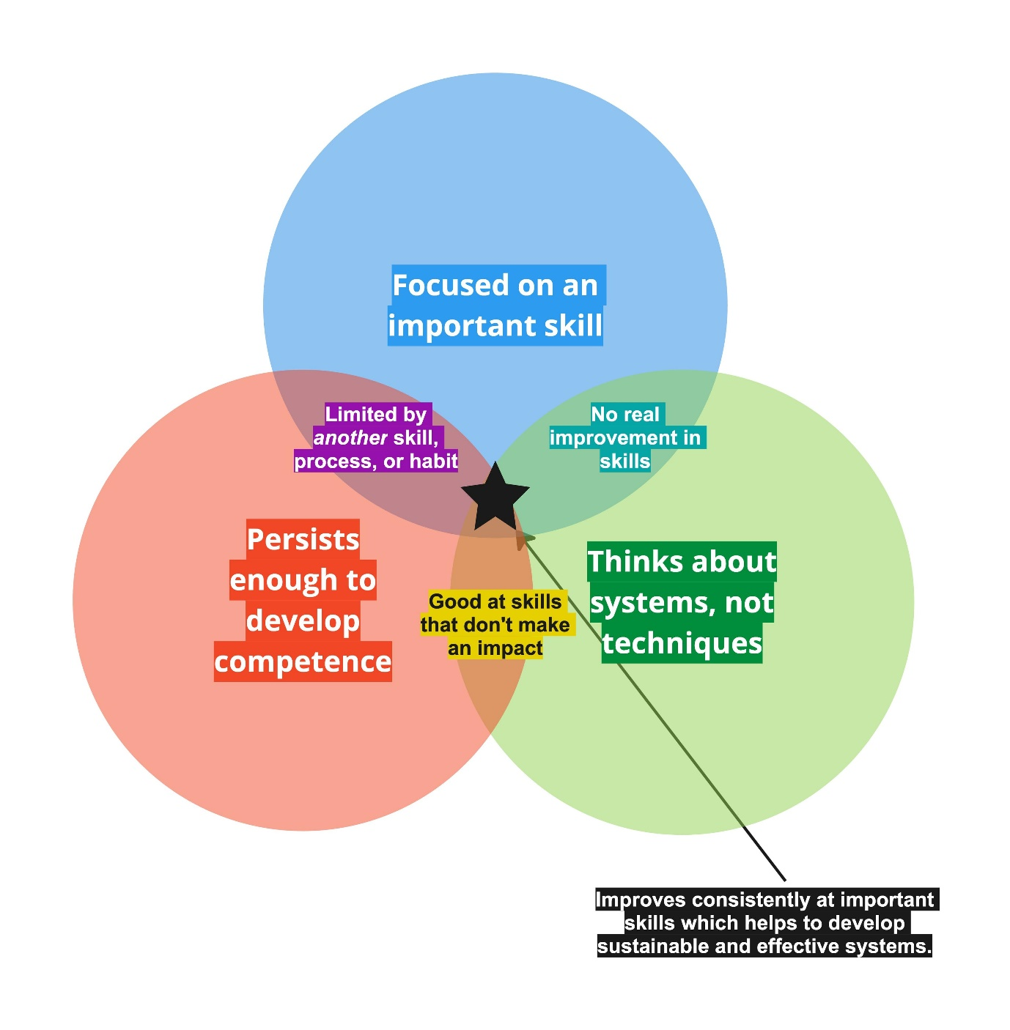
All three aspects must be aligned to improve and create results.
When all three requirements are met, marginal gains help unlock exponential growth and new habit formation.
Exponential growth
Stacking allows future experiments and attempts to build on prior attempts. This compounds the 1% improvement with each attempt, making it easier and easier to improve.
The difference between compounding marginal gains vs. unsustainable "additive" gains is described in Fundamentals 1 here.
New habits
Stacking and being mindful of progressing through marginal gains helps to slowly build new habits that open doors for learning even better techniques and habits. Without new habits, making change requires too much effort and concentration.
Key principles to ensure you correctly stack marginal gains
In addition to the marginal gains tracker, you may find the principles below helpful for a big-picture view of how you can make sure your marginal gains are tackled productively.
Ensure you stack your marginal gains with the REDO guidelines...
- Reflect: Ask yourself what you have learned from your previous marginal gains attempts. Look for trends in progress across multiple attempts. Ask yourself what the next 1% gain might look like?
- Evaluate: Prioritise which direction you want to improve in. Is it to unblock yourself by focusing on another skill? Or is it to unlock the current skill with more experimentation, theory, and reflection?
- Define: Identify what a 1% improvement in your chosen direction might look like? Remember that early improvements often involve simply finding mistakes (before you can see performance improvements). How long might it take to see results?
- Optimise: Create a specific plan for improvement, try it, and reflect again from step 1. While you won't see improvements with each attempt, you should see a clear trend towards more clarity, awareness and (eventually) real performance improvement.
Detailed example
Example case
Sarah wants to improve her essay-writing skills. She has already made some initial progress by improving her ability to brainstorm ideas quickly (i.e. 1% gain).
Now, she wants to stack her marginal gains to further enhance her writing skills.
Reflect
- Sarah realizes that brainstorming helps her generate ideas faster, but she sometimes struggles to present those ideas clearly in her essays.
- She notices a trend that while her idea generation has improved since 2 weeks ago, her essay structure is still not very organised.
- She also finds that it takes her longer to write an essay because she spends longer in idea generation and planning.
Evaluate
- She realises that her competence with idea generation is improving, but her competence with presenting and organising ideas is still low. She makes mistakes and isn't aware of what kinds of mistakes she makes in planning and organising.
- She recognises that speed and efficiency will come with time. Therefore, she prioritises focusing on improving her organisation of ideas without worrying too much about time.
Define
- As she isn't even aware of the mistakes she currently makes during organisation and planning, she identifies that becoming more self-aware of her current tendencies and habits and mistakes would be a 1% improvement.
- As these are habits she has had for years, she anticipates that it may take her at least 10 hours over the next week to find her major mistakes. It may take another week or two to experiment with possible solutions before she can do it better.
Optimise
- She identifies the PEEL (Point, Evidence, Explanation, Link) essay structuring technique as a possible method that could help her organise her thoughts.
- Sarah tries this and find a different set of issues and mistakes. This shows that her awareness of how to be good at this skill is growing! She reflects again for her next round of marginal gains.

